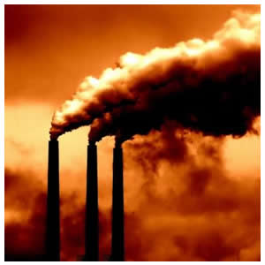
The Environmental Justice
Leadership Forum on Climate Change
Addressing
Climate Change,

Achieving
Climate Justice
Dear Speaker Pelosi,

The looming threat of climate change demands that the U.S. act quickly and aggressively to reduce greenhouse gas emissions. For communities of color and low-income communities, climate change is already having life-and-death effects. These impacts must be taken into account and prioritized in national climate policy.

Our frontline communities know from experience that rushing to create policy can result in negative impacts for vulnerable populations. We cannot gamble our future on a climate policy that doesn’t achieve climate justice.
Climate Justice policy would:
- Dramatically and rapidly reduce CO₂ emissions;
- Address co-pollutant as well as CO₂ emissions;
- Provide an economic safety net for low-income consumers;
- Transition us away from fossil fuels to a clean, green, renewable energy economy.

The American Clean Energy and Security Act (ACES) does not achieve any of these goals and puts environmental justice communities at risk. ACES promotes and protects traditional energy industries at the cost of consumers, delays necessary action and puts all communities at risk.

We can do better than this. The future of our planet and our people demands that we do better. ACES is a gamble on our climate future that we are not willing to take.

Respectfully,

_________________________________
NAME
_________________________________
E-MAIL (Please Print Clearly)
EJ Leadership Forum
C/o WE ACT
ADDRESS
New York, NY 10027
www.weact.org/climatejustice

House Speaker Nancy Pelosi
C/O EJ Leadership Forum on Climate Change
ADDRESS
New York, NY 10027

